Resume of Rashel Hossain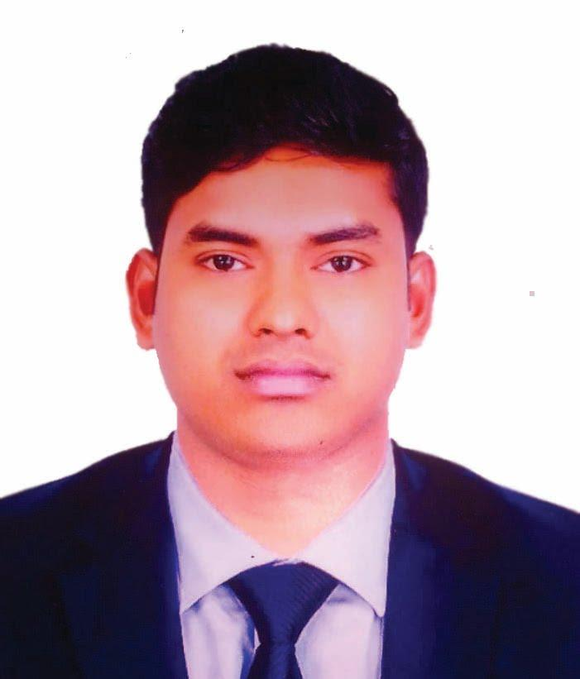

Contact No: +88001942908317

Email: [rashelh73@gmail.com](mailto:rashelh73@gmail.com)

Skype: raselkabir45

**Career Objective:**

Looking for challenging career, where there is scope for demonstration, always on a lookout for a positive & bigger outlook, Currency are ideas, thrive on Imagination & Passion, Rigorous thinking and boundless curiosity, Sets levels & standards that exceed expectations, Have fun attitude is everything, Bottom line rises with the Organization, A Learner for Life.

**Personal Information:**

**Full Name** **:** Rashel Hossain.

**Father’s Name** **:** Md. Manik Miah.

**Mother’s Name :** Maleka Begum.

**Nationality :** Bangladeshi by Birth.

**Date of Birth :** February 23, 1995.

**Sex :** Male.

**Marital status :** Unmarried.

**Religion :** Muslim.

**Present Address :** Graphic Arts Stuff-Quarter, Mohammadpur, Dhaka -1207.

**Permanent Address :** Village: East Kesty, Post-off: Atigram, District: Manikgonj.

**Educational Qualification:**

**IELTS :** Band Score 5.0.

**Institution :** British Council, Dhaka.

**Computer Science & Engineering (Running)**

**Institution :** The People’s University Bangladesh, Dhaka-1207.

**Diploma in Engineering:** Graphic Design Technology.

**Institution :** Govt**.** Graphic Arts Institute, Dhaka-1207.

**Secondary School Certificate (Science) Examination, 2011.**

**Institution :** Jalsha High School, Dhamrai, Dhaka**,** Bangladesh.

**Board :** Bangladesh Education Board, Dhaka.

**GPA :** 4.13 out of 5.00.

**Career and Application Information:**

**Looking For :** Looking ForDynamic Frontend Developer (WordPress).

**Available For :** Full Time.

**Preferred Job Category:** Dynamic Frontend Developer.

**Job Experience : i)** CTP Operator (Avery Dennison, DEPZ, Savar, Dhaka),

Computer Operator (Tanzim Coaching Centre, Mohammadpur, Dhaka).

ii) Printing Executive Officer, Production (Lecture Publications Ltd,

Matuail, Jatrabari, Dhaka)

iii) Computer Operator (Tanzim Coaching Centre, Mohammadpur, Dhaka).

**Expertise:**

**Operating system:**

Windows-, XP Professional, Vista, Windows 7/8/10 & Mac (Professional).

**Office package:**

Microsoft Office Program (All Software).

**Programming Criteria’s:**

HTML-5, CSS, Java, Java-script, Python.

**Application Software’s:**

Visual Studio, Eclipse IDE, PyCharm, Adobe Photoshop, Adobe Illustrator, Adobe-In-Design.

**Networking Skills:**

Local Area Network (LAN), Microsoft Network Internet Browsing.

**Quick and accurate keyboard skills** (English and Bengali)**.**

**Spoken And Written Communication Skill In Both English, Bengali & Hindi.**

**Specialty:**

1. Punctual and Committed to Work.
2. Responsible and Disciplined.
3. Feel Comfort to Work with Group.
4. Able to Understand Matters Easily.

**Reference:**

Pankaj Kumar Sutradhar.

**Instructor (**Tech**).**

**Phone:** 01556333910.

**Govt. Graphic Arts Institute, Dhaka-1207**.

**Declaration:**

In my knowledge all the information that I have written in my curriculum vitae is true. I will give if further any information is needed.

**Rashel Hossain**